DAY 5

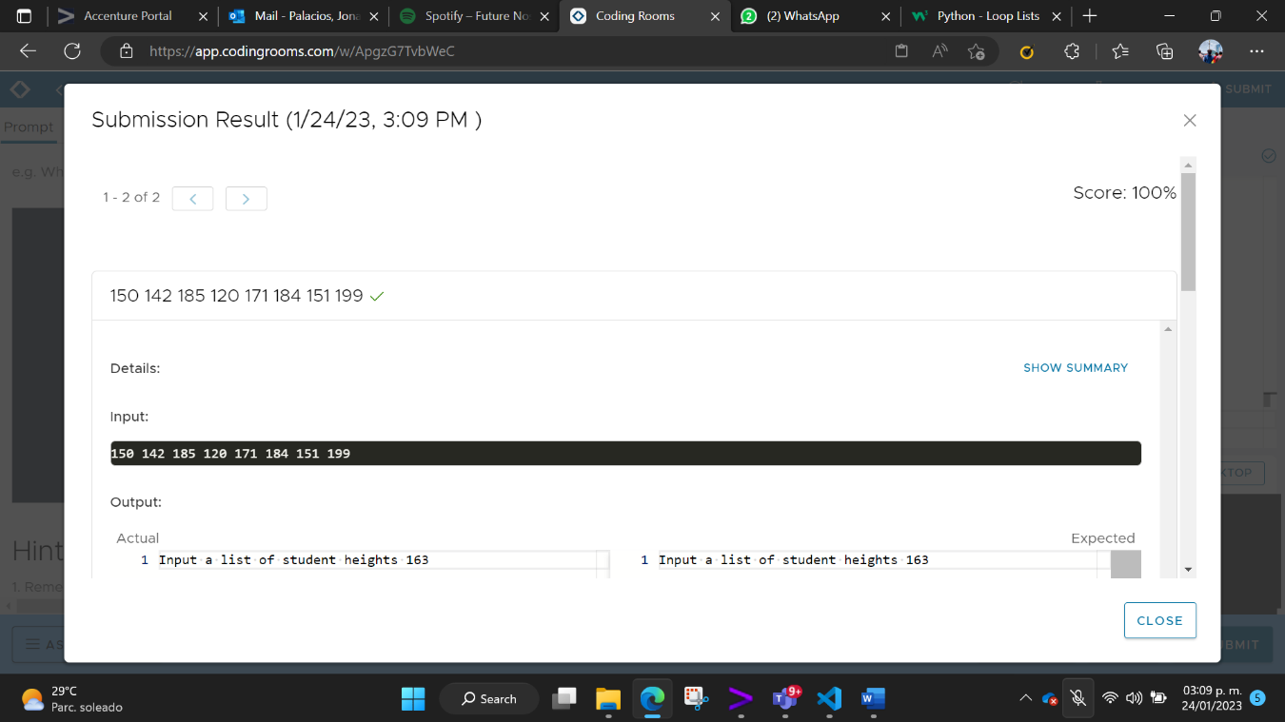AVERAGE HEIGHT

HIGH SCORE

ADDING NUMBERS



10 NUMEROS NATURALES CON WHILE

SUMAR ARCHIVOS

